SCHOOL OF COMPUTER SCIENCE AND ARTIFICIAL INTELLIGENCE |  |  |  |  | DEPARTMENT OF COMPUTER SCIENCE ENGINEERING
Program Name: B. Tech |  |  |  | Assignment Type: Lab |  |  | Academic Year:2025-2026
Course Coordinator Name |  |  |  | Venkataramana Veeramsetty
Instructor(s) Name |  |  |  | Dr. V. Venkataramana (Co-ordinator)  Dr. T. Sampath Kumar  Dr. Pramoda Patro  Dr. Brij Kishor Tiwari  Dr.J.Ravichander  Dr. Mohammand Ali Shaik  Dr. Anirodh Kumar  Mr. S.Naresh Kumar  Dr. RAJESH VELPULA  Mr. Kundhan Kumar  Ms. Ch.Rajitha  Mr. M Prakash  Mr. B.Raju  Intern 1 (Dharma teja)  Intern 2 (Sai Prasad)  Intern 3 (Sowmya)  NS_2 ( Mounika)
Course Code |  |  | 24CS002PC215 | Course Title |  | AI Assisted Coding
Year/Sem |  |  | II/I | Regulation |  | R24
Date and Day  of Assignment |  |  | Week9 - Tuesday | Time(s)
Duration |  |  | 2 Hours | Applicable to  Batches
AssignmentNumber:16.2(Present assignment number)/24(Total number of assignments)
 | Q.No. | Question |  |  |  |  |  | Expected Time  to complete
 | 1 | - Display all records from the employee’s table.  Query:SELECT * FROM employees;  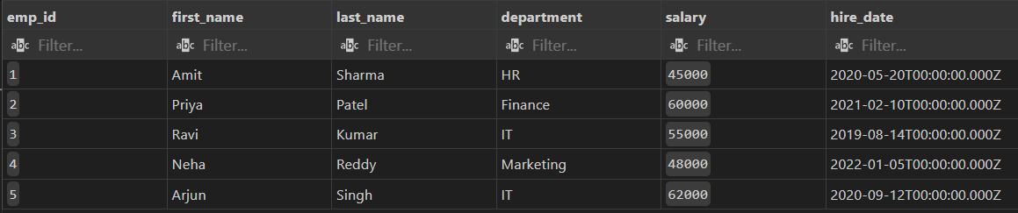  - 2. Display only employee names and their departments.  Query:SELECT first_name, last_name, department FROM employees;  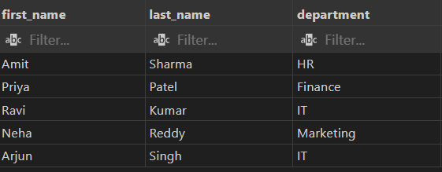  - 3. Show unique department names.  Query:SELECT DISTINCT department FROM employees;  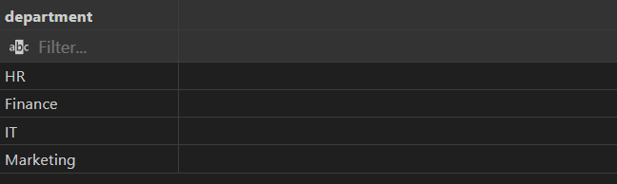  - 4. Find employees with salary greater than 50000.  Query:SELECT * FROM employees WHERE salary > 50000;  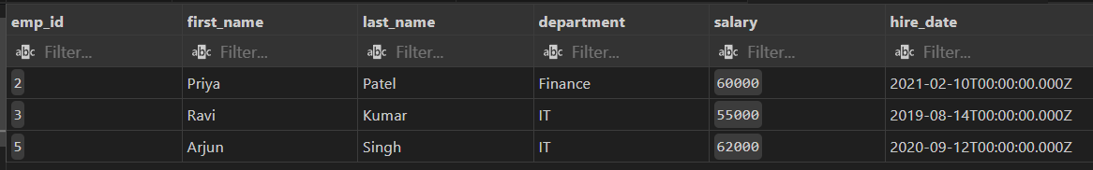  - 5. Find employees from the IT department.  Query:SELECT * FROM employees WHERE department = 'IT';    - 6. Display employees hired after 2020.  Query:SELECT * FROM employees WHERE hire_date > '2020-01-01';  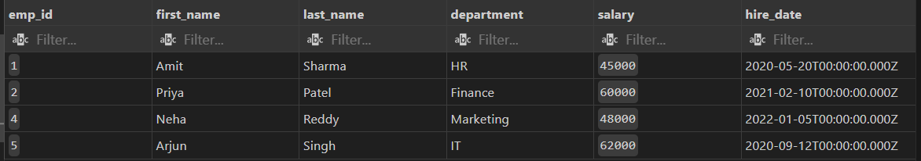  - 7. Show employees in ascending order of salary.  Query:SELECT * FROM employees ORDER BY salary ASC;  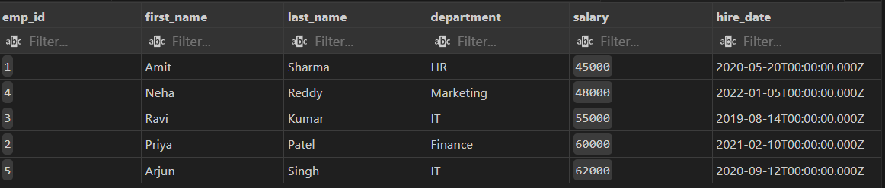  - 8. Show top 3 highest-paid employees.  Query:SELECT * FROM employees ORDER BY salary DESC LIMIT 3;  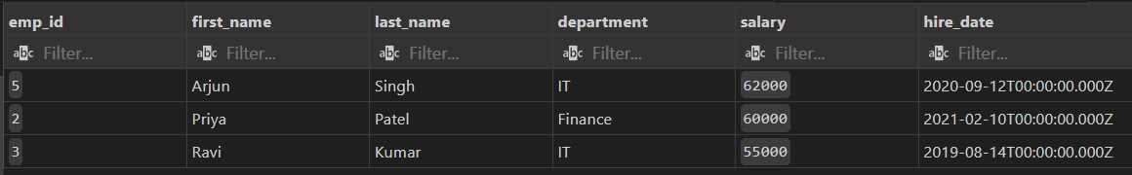  - 9. Count total employees in the company.  Query:SELECT COUNT(*) AS total_employees FROM employees;  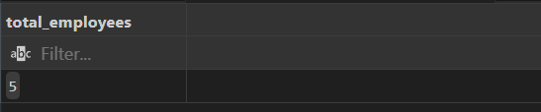  - 10. Find the average salary of employees.  Query:SELECT AVG(salary) AS average_salary FROM employees;  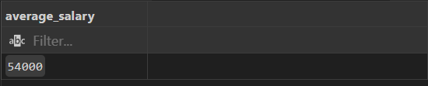  - 11. Find the highest and lowest salary.  Query:SELECT MAX(salary) AS highest_salary FROM employees;  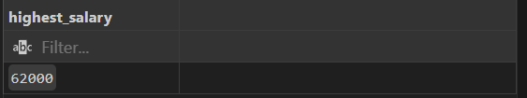  SELECT MIN(salary) AS lowest_salary FROM employees;  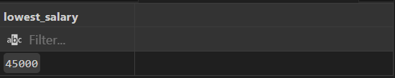  - 12. Find total salary expenditure per department.  Query:SELECT department, SUM(salary) AS total_salary_expenditure  FROM employees  GROUP BY department;  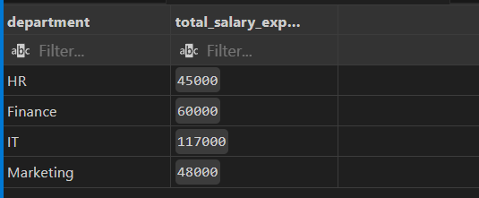  - 13. Display departments having more than one employee.  Query:SELECT department  FROM employees  GROUP BY department  HAVING COUNT(*) > 1;    - 14. Show average salary by department.  Query:SELECT department, AVG(salary) AS average_salary  FROM employees  GROUP BY department;  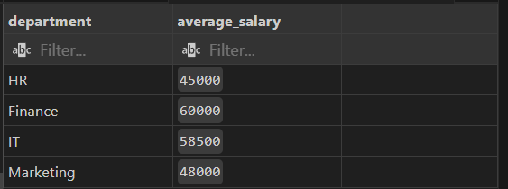  - 15. Count employees hired each year.  Query:SELECT YEAR(hire_date) AS hire_year, COUNT(*) AS employees_hired  FROM employees  GROUP BY YEAR(hire_date)  ORDER BY hire_year;  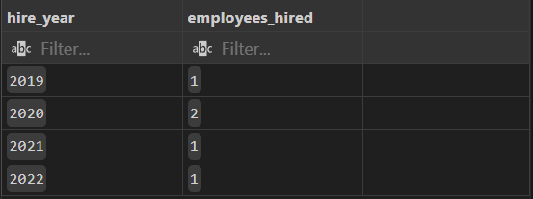  - 16. List employees with their department locations.  Query:SELECT e.emp_id, e.first_name, e.last_name, e.department, d.location  FROM employees e  JOIN department d ON e.department = d.dept_name;  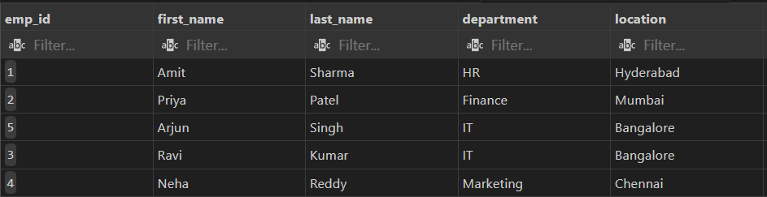  - 17. Find employees working in Bangalore.  Query:SELECT e.*  FROM employees e  JOIN department d ON e.department = d.dept_name  WHERE d.location = 'Bangalore';    - 18. Display all employees even if they don’t belong to a department.  Query:SELECT e.*  FROM employees e  LEFT JOIN department d ON e.department = d.dept_name;  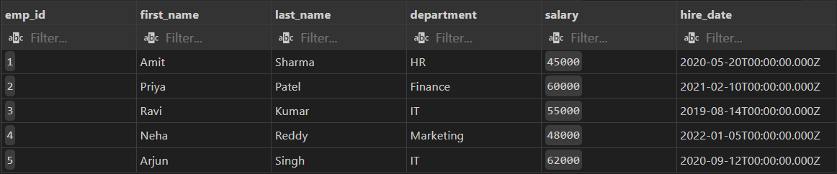  - 19. Find departments with no employees.  Query:SELECT d.dept_name  FROM department d  LEFT JOIN employees e ON d.dept_name = e.department  WHERE e.emp_id IS NULL;  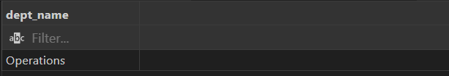  - 20. Count employees in each department.  Query:SELECT department, COUNT(*) AS employee_count  FROM employees  GROUP BY department;  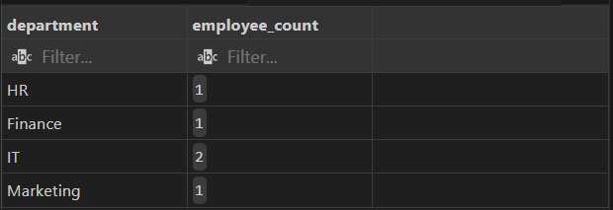  - 21. Find employees earning above average salary.  Query:SELECT *  FROM employees  WHERE salary > (SELECT AVG(salary) FROM employees);  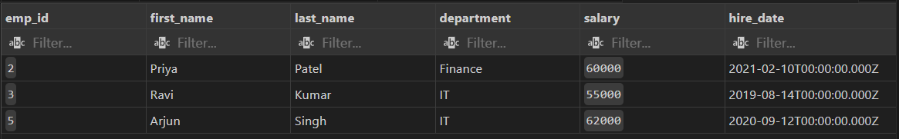  - 22. Find the department with the highest average salary.  Query:SELECT department, AVG(salary) AS avg_salary  FROM employees  GROUP BY department  ORDER BY avg_salary DESC  LIMIT 1;  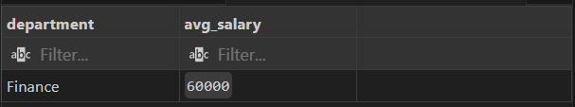  - 23. Find employees hired most recently.  Query:SELECT *  FROM employees  ORDER BY hire_date DESC  LIMIT 1;  - 24. Find employees earning the second highest salary.  Query:SELECT *  FROM employees  WHERE salary = (  SELECT MAX(salary)  FROM employees  WHERE salary < (SELECT MAX(salary) FROM employees)  );  - 25. Find all employees in the same department as 'Amit Sharma'.  Query:SELECT *  FROM employees  WHERE department = (SELECT department FROM employees WHERE first_name = 'Amit' AND last_name = 'Sharma');  - 26. Increase salary by 10% for IT employees.  Query:UPDATE employees  SET salary = salary * 1.10  WHERE department = 'IT';  - 27. Change department of employee 'Ravi' to Marketing.  Query:UPDATE employees  SET department = 'Marketing'  WHERE first_name = 'Ravi';  - 28. Delete employees with salary below 40000.  Query:DELETE FROM employees  WHERE salary < 40000;  - 29. Add a new column 'email' to employees.  Query:ALTER TABLE employees  ADD email VARCHAR(100);  - 30. Update email IDs for all employees.  Query:UPDATE employees  SET email = CONCAT(LOWER(first_name), '.', LOWER(last_name), '@example.com');  - 31. Find top 2 departments by average salary.  Query:SELECT department, AVG(salary) AS avg_salary  FROM employees  GROUP BY department  ORDER BY avg_salary DESC  LIMIT 2;  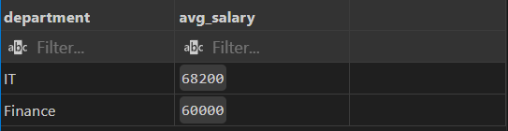  - 32. Find how many employees work in each city.  Query:SELECT d.location, COUNT(e.emp_id) AS employee_count  FROM employees e  JOIN departments d ON e.department = d.dept_name  GROUP BY d.location;  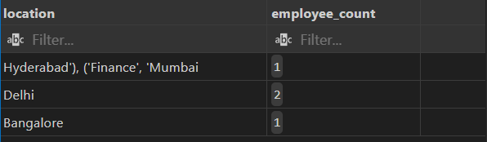  - 33. Show employee count and total salary together.  Query:SELECT COUNT(*) AS employee_count, SUM(salary) AS total_salary  FROM employees;    - 34. Display employees with names starting with 'A'.  Query:SELECT *  FROM employees  WHERE first_name LIKE 'A%';  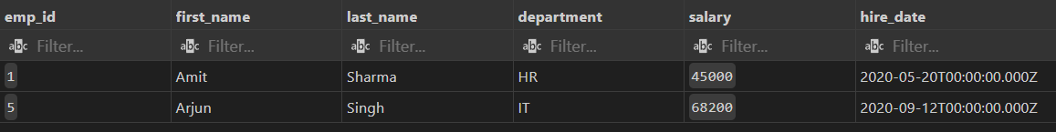  - 35. Display employees whose last name ends with 'a'.  Query:SELECT *  FROM employees  WHERE last_name LIKE '%a';  - 36. Find employees hired in 2020.  Query:SELECT *  FROM employees  WHERE YEAR(hire_date) = 2020;    - 37. Show number of days since each employee was hired.  Query:SELECT first_name, last_name, DATEDIFF(CURDATE(), hire_date) AS days_since_hire  FROM employees;  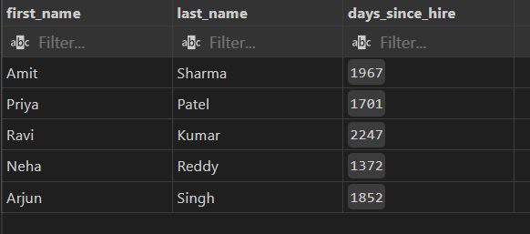  - 38. Display employee names in uppercase.  Query:SELECT UPPER(first_name) AS first_name, UPPER(last_name) AS last_name  FROM employees;  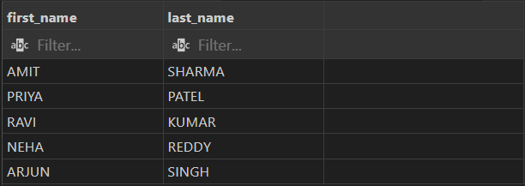  - 39. Concatenate first and last names.  Query:SELECT CONCAT(first_name, ' ', last_name) AS full_name  FROM employees;  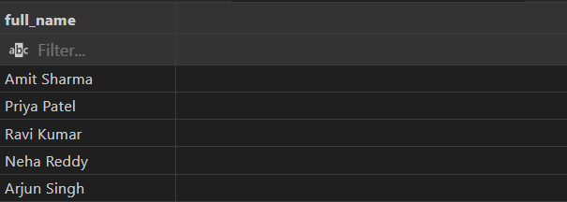  - 40. Find employees whose salary is between 45000 and 60000.  Query:  SELECT *  FROM employees  WHERE salary BETWEEN 45000 AND 60000;  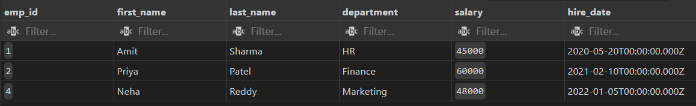  - 41. Create a view for high salary employees (>55000).  Query:CREATE VIEW high_salary_employees AS  SELECT * FROM employees  WHERE salary > 55000;  - 42. Display all records from the view.  Query:SELECT * FROM high_salary_employees;  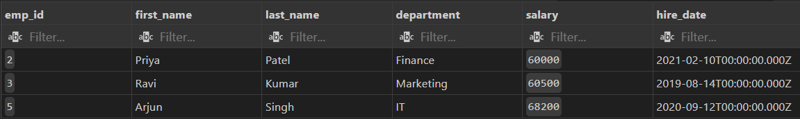  - 43. Add NOT NULL constraint to department name.  Query:ALTER TABLE employees  MODIFY department VARCHAR(50) NOT NULL;  - 44. Drop the view.  Query:DROP VIEW high_salary_employees;  - 45. Rename the employees table to staff.  Query:ALTER TABLE employees RENAME TO staff;  - 46. Create a backup copy of the employees table.  Query:CREATE TABLE employees_backup AS SELECT * FROM employees;  - 47. Delete all data but keep the structure.  Query:DELETE FROM employees;  - 48. Drop the employees backup table.  Query:DROP TABLE employees_backup;  - 49. Create an index on employee last name.  Query:CREATE INDEX idx_last_name ON employees(last_name);  - 50. Drop the index.  Query:  DROP INDEX idx_last_name ON employees; |  |  |  |  |  | Week9 - Monday

Employee Table
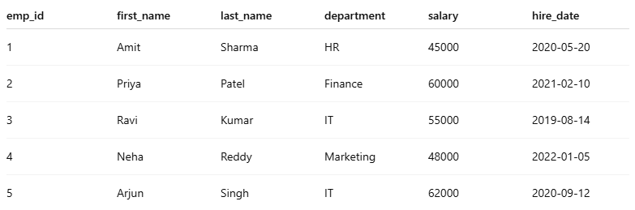

Department Table

